

A PROJECT REPORT ON

**“Courier Management System”** SUBMITTED BY:

**Miss. Ghumare Arohi Shantaram**

(2124UCEF1093)

SUBJECT: **C++** PROGRAMMING

Under the guidance of **Prof. Ishwari Tirse**

Department of **Computer Science and Engineering**

Sanjivani Rural Education Society’s

SANJIVANI UNIVERSITY

KOPARGAON – 423603 (2024-2025)

# INDEX

|  |  |  |
| --- | --- | --- |
| Sr No. | Content | Page No. |
| 1 | INTRODUCTION | 3 |
| 2 | CODE | 4 |
| 3 | OUTPUT | 9 |
| 4 | CONCLUSION | 11 |

# INTRODUCTION

The Courier Management System is a C++ application designed to streamline the management of courier services. In today’s fast-paced world, efficient tracking and delivery of parcels are crucial for customer satisfaction. This application provides an intuitive platform for users to easily record, manage, and monitor their shipments.

Leveraging C++ for its performance and memory management capabilities, the system incorporates fundamental programming concepts to ensure seamless handling of courier entries and status updates. It aims to enhance operational efficiency while simplifying the logistics process for users.

# CODE

#include <iostream>

#include <vector>

#include <string>

using namespace std;

class Courier { public:

string trackingNumber; string senderName; string recipientName; string status;

Courier(string tracking, string sender, string recipient, string stat)

: trackingNumber(tracking), senderName(sender), recipientName(recipient), status(stat) {}

};

class CourierManagementSystem { private:

vector<Courier> couriers;

public:

void addCourier(const Courier& courier) { couriers.push_back(courier);

cout << "Courier added successfully!" << endl;

}

void displayCouriers() { cout << "\nCourier List:\n"; for (const auto& courier : couriers) {

cout << "Tracking Number: " << courier.trackingNumber

<< ", Sender: " << courier.senderName

<< ", Recipient: " << courier.recipientName

<< ", Status: " << courier.status << endl;

}

}

void updateCourierStatus(const string& trackingNumber, const string&

newStatus) { for (auto& courier : couriers) { if (courier.trackingNumber == trackingNumber) { courier.status = newStatus;

cout << "Status updated successfully!" << endl; return;

}

}

cout << "Courier not found!" << endl;

}

};

int main() {

CourierManagementSystem cms;

while (true) {

cout << "\nCourier Management System\n"; cout << "1. Add Courier\n"; cout << "2. Display Couriers\n"; cout << "3. Update Courier Status\n"; cout << "4. Exit\n"; cout << "Enter your choice: ";

int choice; cin >> choice;

if (choice == 1) {

string trackingNumber, senderName, recipientName, status; cout << "Enter Tracking Number: "; cin >> trackingNumber; cout << "Enter Sender Name: "; cin >> senderName;

cout << "Enter Recipient Name: "; cin >> recipientName; cout << "Enter Status: "; cin >> status;

cms.addCourier(Courier(trackingNumber, senderName, recipientName, status));

} else if (choice == 2) { cms.displayCouriers(); } else if (choice == 3) {

string trackingNumber, newStatus; cout << "Enter Tracking Number to update: "; cin >> trackingNumber;

cout << "Enter New Status: "; cin >> newStatus;

cms.updateCourierStatus(trackingNumber, newStatus);

} else if (choice == 4) { break;

} else {

cout << "Invalid choice! Please try again." << endl;

}

}

return 0;

}

# OUTPUT

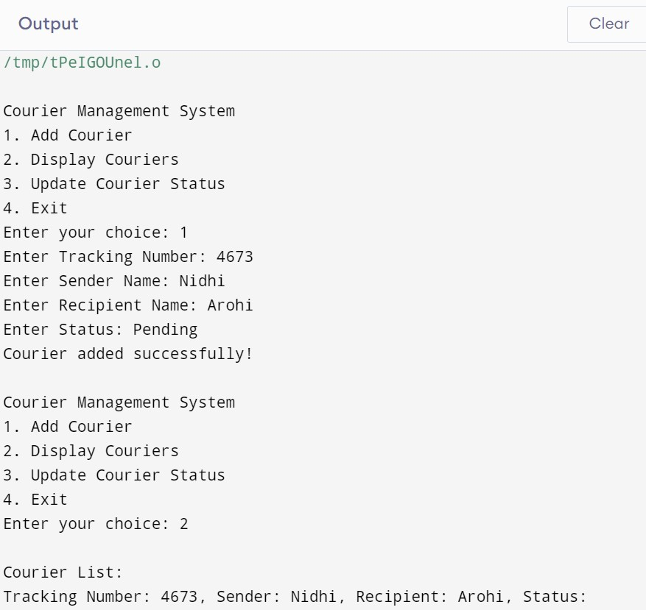

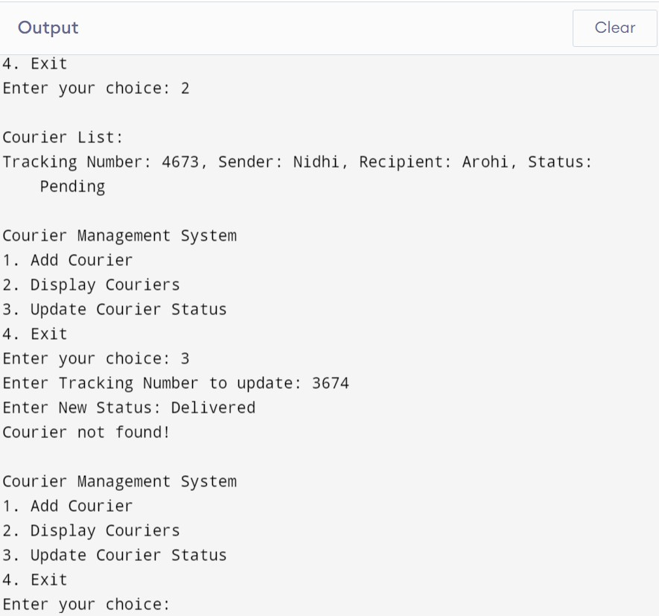

# CONCLUSION

In conclusion, the Courier Management System in C++ is a practical and efficient tool for managing courier services. It enables users to easily add, track, and update shipments, ensuring a streamlined logistics process. With its user-friendly interface, this application simplifies the management of deliveries, helping users enhance operational efficiency and improve customer satisfaction. Overall, it serves as an essential resource for anyone involved in courier management.